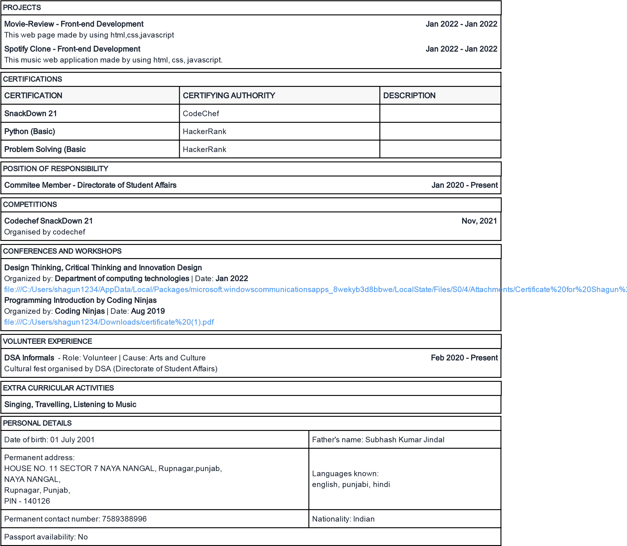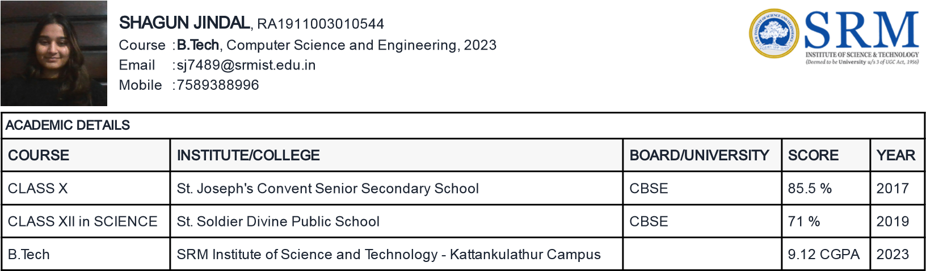

|  |  |
| --- | --- |
| Subjects / Electives | Introduction to HTML5, Building Web Applications in PHP |
| Technical Proficiency | C++, Data Structures, Machine Learning, HTML5, Web Development, Front-End Web Development |